6A^{th} Grade: Unit 13, Lesson 4

- Which example is correct?
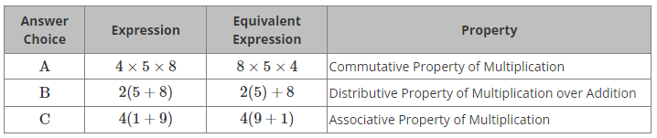

A

- What is another way to write the expression 6(7+2-5) using three terms?

6(7)+6(2)-6(5) or 42+12-30

- What is the value of the expression 9(3+5)+4?

76

